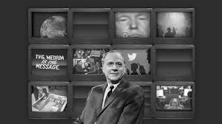

Marshall McLuhan's tetrad of media effects uses a tetrad to examine the effects on society of any technology/medium (put another way: a means of explaining the social processes underlying the adoption of a technology/medium) by dividing its effects into four categories and displaying them simultaneously. The tetrad first appeared in print in McLuhan's posthumously-published works Laws of Media (1988) and The Global Village (1989),

The tetrad consists of four questions.
- What does the medium enhance?
- What does the medium make obsolete?
- What does the medium retrieve that had been obsolesced earlier?
- What does the medium reverse or flip into when pushed to extremes?

The laws of the tetrad exist simultaneously, not successively or chronologically, and allow the questioner to explore the "grammar and syntax" of the "language" of media. McLuhan departs from the media theory of Harold Innis in suggesting that a medium "overheats", or reverses into an opposing form, when taken to its extreme.^{[4]}
Visually, a tetrad can be depicted as four diamonds forming an X, with the name of a medium in the center. The two diamonds on the left of a tetrad are the Enhancement and Retrieval qualities of the medium, both Figure qualities. The two diamonds on the right of a tetrad are the Obsolescence and Reversal qualities (see further below).
- Enhancement (figure): What the medium amplifies or intensifies. For example, “Grammarly” software amplifies editing.
- Obsolescence (ground): What the medium drives out of prominence. The software reduces the prominence of print resources such as dictionary or thesaurus.
- Retrieval (figure): What the medium recovers which was previously lost. Models and supports editing for writing standards
- Reversal (ground): What the medium does when pushed to its limits. The software reduces standardized writing through over-reliance.

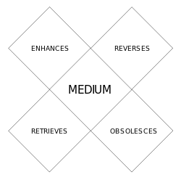
A blank tetrad diagram

